**Statistical Analysis Report: New England Patriots**

**Student Name(s)**: Erick Mendez Hugo Salazar, Jada Manning, Carlos Lozoya, Pablo Garcia.

**Subject**: Sports Statistics

**Team**: New England Patriots

**Duration**: [1960-2023]

**Executive Summary:**

Provide a brief overview of the key findings and insights obtained from the statistical analysis of the New England Patriots' performance data.

**Introduction:**

In the realm of sports analytics, algebra plays a crucial role in predicting performance outcomes and uncovering the mathematical foundations behind sports successes. By utilizing algebraic equations and formulas, analysts can delve into player or team statistics to gain valuable insights and make informed decisions based on data-driven predictions.

One common application of algebra in sports analytics is the creation of predictive models to forecast player performance. Analysts can use historical data, such as past game statistics, player attributes, and environmental factors, to develop algebraic equations that estimate future outcomes. These models can help teams identify key performance indicators, optimize strategies, and maximize player potential.

Algebra also enables analysts to calculate advanced metrics that go beyond basic statistics. For instance, in basketball, algebraic formulas can be used to determine a player’s efficiency rating by considering a range of factors like points scored, rebounds, assists, and playing time

**Data Collection and Sources:**

* <https://overthecap.com/salary-cap/new-england-patriots>[https://www.patriots.com/team/stats/ rTk7u7EzMmp5Djt4ubF6hHOtVnR7lsm2HkbUYzg_r5RLYtYYSX55C2FNkyi_OZbxt3xKcHtctp8vmoHZBgQcTbha77pUQRGsrDfyC1tZe4kQ](https://www.patriots.com/team/stats/) <https://growingeers.com/posts/2018/12/11/all-the-math-involved-in-the-superbowl> [https://www.cbssports.com/nfl/teams/NE/n https://www.buccaneers.com/news/tom-brady-career-stats-records-nfl-2000-2022-patriots-bucs#:~:text=Tom%20Brady%20ranks%20first%20all%2Dtime%20in%3A&text=Completions%3A%207%2C753,Passing%20Touchdowns%3A%20649](https://www.cbssports.com/nfl/teams/NE/new-england-patriots/stats/regular/)
* •<https://www.patriots.com/team/stats/2023/PRE>

•<https://sports.yahoo.com/nfl/teams/new-england/stats/>

**Historical Performance Overview:**

**Wins and Losses:**

* The Patriots have consistently been competitive throughout their history, with numerous winning seasons.
* As of the end of the 2020 NFL season, the Patriots have recorded over 500 regular-season wins.

**Championships:**

* The New England Patriots have won 6 Super Bowl championships, tied for the most in NFL history with the Pittsburgh Steelers.
* Their Super Bowl victories came in the following years: 2001 (Super Bowl XXXVI), 2003 (Super Bowl XXXVIII), 2004 (Super Bowl XXXIX), 2014 (Super Bowl XLIX), 2016 (Super Bowl LI), and 2018 (Super Bowl LIII).

**Playoff Appearances:**

* The Patriots have made numerous playoff appearances throughout their history.
* They have clinched AFC East division titles on multiple occasions, securing playoff berths.

**Key Statistics:**

* The team has had several Hall of Fame players and legendary coaches who have contributed to their success.
* Quarterback Tom Brady played a significant role in the team’s success during his tenure with the Patriots.
* Head coach Bill Belichick is widely regarded as one of the greatest coaches in NFL history.

Overall, the New England Patriots’ historical performance is characterized by sustained success, multiple championships, and a winning culture that has made them a dominant force in the NFL for decades.

**Season-by-Season Analysis:**

* **Season 1 (Year) - Season N (Year)**:
  + Provide a summary of each season, including win-loss records, playoff results, key player performances, notable events, etc.
  + Present graphical representations (charts, graphs) of key statistics over each season.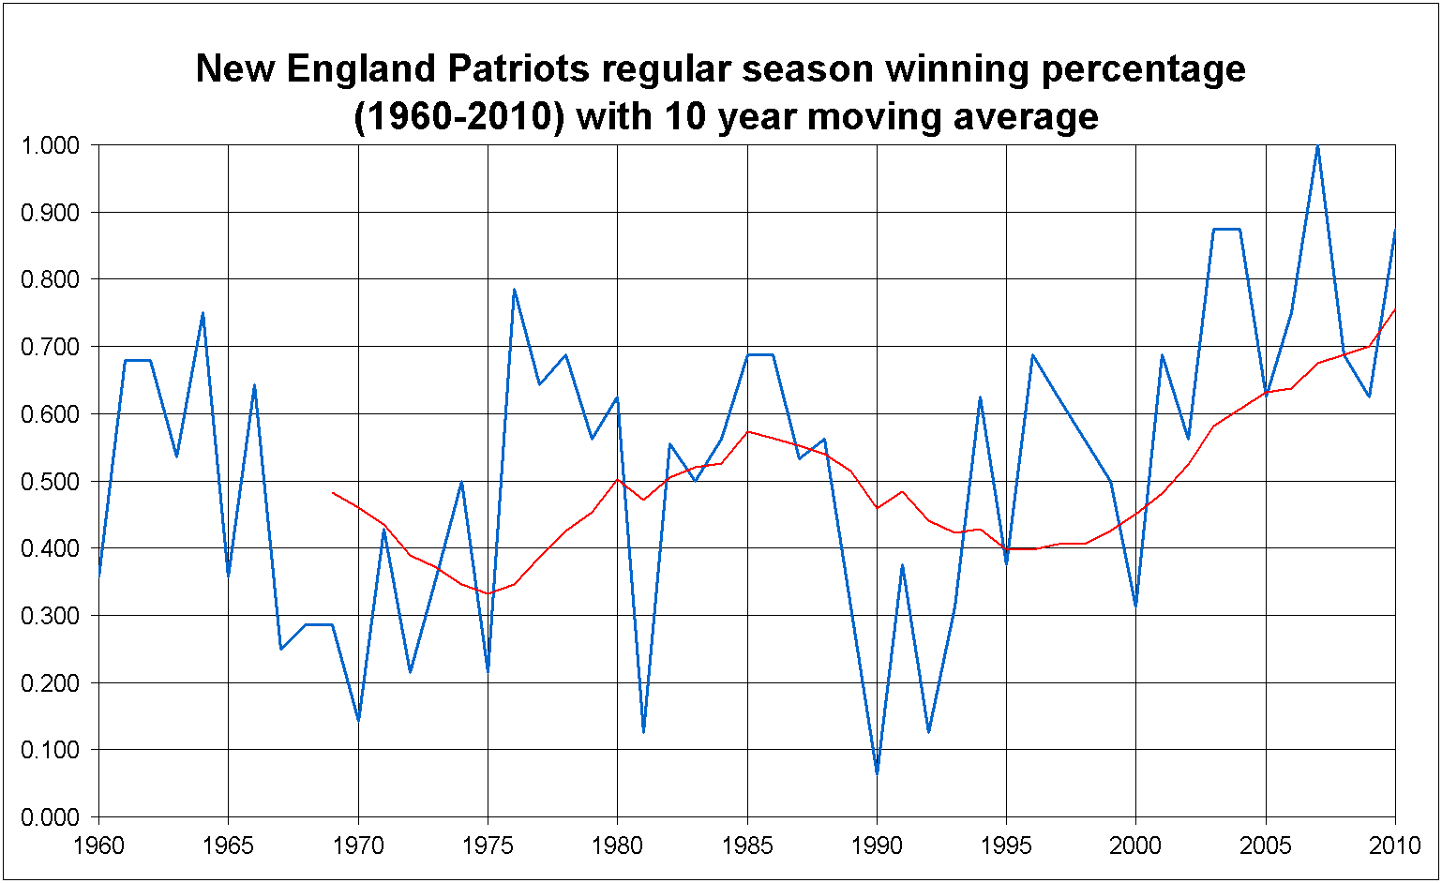
  + Identify trends or patterns in the team's performance over time.

**Player Performance Analysis:**

* **Top Players**:
  + One of the top players that benefit the team would be Tom Brady since in his overall stats he has had 7,753 completions, 12,050 attempts, ran 89,214 yards (about 81.58 km) ran and 649 touchdowns due to his incredible calculations and plays he makes to make sure they score and come out on top.
  + Include metrics such as touchdowns, yards gained, interceptions, tackles, etc.
* **Key Contributors**:
  + By using hybrid safeties who can play at all three levels, the Patriots can play dime defense at the third-highest rate in the NFL (22.8%). The Pats get away with lighter personnel, thus adding speed and coverage ability because hybrids like Peppers, Dugger, Mapu, Bryant, and Jalen Mills have the strength to hold up at the point of attack and are good blitzers. Dugger ranks fourth among all defensive backs with 15 quarterback pressures, while Peppers is tied for fourth with 17 run stops.
  + New England is also highly exotic in how they rush the passer, using schemes such as "creepers" at the fifth-highest rate and are third in cover zero usage (8%). With all the dialed-up pressure, the Patriots have the second-highest rate of unblocked pressures in the NFL this season (10.9%). Belichick is still a wizard at flummoxing quarterbacks and scheming up pressure.

**Comparative Analysis:**

* **Comparison with Other Teams**:
  + **New York Jets vs. New England Patriots Comparison:**
* When comparing the New York Jets and the New England Patriots, several aspects can be considered to understand the differences between these two NFL teams.
* **1. Team History and Success:**
* The New England Patriots have been one of the most successful teams in the NFL, with multiple Super Bowl victories under the leadership of legendary coach Bill Belichick and former quarterback Tom Brady.
* In contrast, the New York Jets have not enjoyed the same level of success as the Patriots, having faced challenges in consistently performing at a high level and securing championships.
* **2. Roster and Players:**
* The Patriots have had star players like Tom Brady (in the past) and currently feature standout performers such as Mac Jones, who has shown promise as a young quarterback.
* The Jets, on the other hand, have been rebuilding their roster in recent years and have young talents like Zach Wilson who are seen as key pieces for their future success.
* **3. Coaching Staff and Management:**
* Bill Belichick, known for his strategic coaching style, has been a long-standing figure for the Patriots and has played a significant role in their success over the years.
* The Jets have undergone coaching changes and management restructuring to improve their performance and build a competitive team that can challenge top opponents like the Patriots.
* **4. Head-to-Head Matches:**
* When looking at head-to-head matchups between the Jets and Patriots, historical data may show trends in performance, scoring patterns, and overall competitiveness between these two teams.
* **5. Fan Base and Support:**
* Both teams have dedicated fan bases that support them through thick and thin, showing loyalty to their respective franchises regardless of wins or losses.
* In conclusion, while both the New York Jets and New England Patriots are part of the NFL and compete in the same league, they differ in terms of historical success, current roster composition, coaching staff dynamics, head-to-head performances, and fan base characteristics.
* To analyze how the New England Patriots’ performance stacks up against league averages or historical benchmarks, we need to consider various key metrics such as win-loss records, offensive and defensive statistics, playoff appearances, Super Bowl victories, and overall team success over a specific period.
* **The New England Patriots have established themselves as one of the most successful franchises in NFL history. With multiple Super Bowl victories under head coach Bill Belichick and quarterback Tom Brady, they have consistently outperformed many other teams in terms of win-loss records, playoff appearances, and overall team success. Their ability to maintain a high level of performance over an extended period sets them apart from most teams in the league. When comparing their performance against historical benchmarks, the Patriots stand out as a model of sustained excellence in professional football.**

**Statistical Insights and Findings:**

* **Strengths and Weaknesses**: **The New England Patriots’ primary strengths in the 2022 NFL season include their strong safety room, led by Devin McCourty, Adrian Phillips, Kyle Dugger, and Jabrill Peppers. Their offense, under the direction of Bill Belichick and Mac Jones, is also a strength, with potential improvements in the passing game and the installation of a Shanahan-centric scheme.**
* **One of their notable weaknesses is their secondary, particularly at cornerback. The departure of Jalen Mills and the retirement of James White have left gaps that need to be filled. The offensive line is another area of concern, with questions surrounding the flip tackles and the installation of a new offense.**
* I**Factors Influencing Performance**: **Despite these weaknesses, the Patriots have shown flashes of greatness in their first few games. Their defense has been solid against the pass and has shown improvement in late-game situations. However, they have struggled against the run at times and have been vulnerable to big plays.**

**Conclusion:**

Summarize the key insights obtained from the statistical analysis of the New England Patriots' performance data. Reflect on the significance of the findings and potential implications for future performance. Overall, algebra is massively used in football to make plays that’ll ensure the win for the patriots. Many equations and formulas are used to calculate a certain throw or how fast a player needs to run to get to the ball in time or catch it. That pats have been through a lot and won many championship and super bowls.

**Recommendations:**

(Agent): Recommendation of our report, what we have seen is a team that is widely specialize in defending and offending, with these high time scoring players, we will give advice as to ensuring their victory, I would recommend that the patriots team should optimizes in predicting on what may occur. By this i mean coming up with a game plan on the beginning of the game as it starts and keeping a record on who put in more effort, we can also watch the distant of each player and by looking at the V (velocity of how much they threw the ball) This will help us ensure that the patriots will win

**References:**

Include a list of references or sources used for data collection and analysis.

Vx = V cos(theta)

Vy = V sin(theta)

Changing directions on the Field

a=(vf - vo)/(tf - to)

a=(vf - vo)/(tf - to)

vf is final velocity

vo is initial velocity

tf is final time

to is initial time

**Appendices:**

* Include additional charts, tables, or statistical analyses that support the findings presented in the report.
* Any additional data or information relevant to the analysis can be included in this section.

